VICTORIA JUNIOR COLLEGE
JC2 PRELIMINARY EXAMINATION P2 2026
H2 GEOGRAPHY PAPER 2 9173/02

MARK SCHEME
Section A

Qn |  | Answer | Marks
1 | (a) | Explain one strength and one weakness of the students’ hypothesis. | [4]
Award 1 mark per identification of strength of weakness and an additional mark for elaboration of each strength and weakness.

Possible responses include:

Strength
- [Testable] There are clear independent and dependent variables that can be tested. Independent being participation in community gardens and dependent being adoption of sustainable food practices [1]. This can be measured using questionnaires, interviews and observations [1].
- [Scale] There is a specific scale defined – Detroit. It is a manageable scale for the students to investigate [1]. This will also narrow down the investigation as they will only focus on residents of Detroit [1].

Weakness
- [Broad Variable] The variable of sustainable food practices is rather broad [1] and may include various behaviours such as composting, rainwater harvesting, reducing food wastage and buying local food [1].
- [Broad Variable] Participation in community gardens may also include various practices; some which may be more impactful than others. [1]

Accept any other plausible response.

AO1

1 | (b) | With reference to Resource 1, explain why the chosen sites are suitable for the investigation. | [4]
Award 1 mark for every explanation up to a maximum of 4 marks.
Award a maximum of 1 additional mark for further development of each point.

Possible responses include:
- [Presence of Gardens] District 5 has multiple community gardens and a couple of large-scale urban farming as well. Hence the students will definitely be able to acquire primary data when conducting the research there [1]. The sites chosen are also near clusters of community gardens allowing access to interviewees [1].
- [Coverage within district 5] The sites chosen within District 5 also cover various regions of the district. This ensures good representativeness within the district itself. [1]
- [Representativeness – resident composition] District 5 has a residential composition of mixed-income status. This will ensure that there is a variety of residents being surveyed/interviewed which will enhance the representativeness of the data collected. [1]

AO2
1 | (c) | Identify three ethical issues that may arise from conducting the participant observation and suggest how the students can address these issues. | [6]
Award 1 mark for ethical issue identified up to a maximum of 3 marks.
Award 1 mark for every solution suggested up to a maximum of 3 marks.

Possible responses include:

- [Lack of informed consent] As investigators are observing while participating in gardening activities, some participants may not be aware that they are being observed and recorded. [1]
- Whenever researchers are on the ground joining in the activities, they could wear a tag to let others know that they are doing a research and conduction observation studies. They could also ask the garden owners to let the regular participants know of their presence. [1]
- [Photographs privacy] Photographs taken during the observations may reveal participants’ identities without their permission. [1]
- Researchers should obtain permission before taking photographs. They can also ensure that the faces of the participants in the photographs will be blurred before publication. [1]
- [Confidentiality of personal information] During participant observations, researchers may learn sensitive information about participants that they may not wish to be disclosed – this could include, age, employment status, family status etc. [1]
- Researchers can keep all personal information safe and not include in the final publication of data. [1]

AO1

1 | (d) | Explain the value of conducting participant observations with the interviews. | [5]
Award 1 mark for every explanation up to a maximum of 5 marks.
Award a maximum of 1 additional mark for further development of each point.

Possible responses include:

- [Data Triangulation] Participant observation allows researchers to verify whether what interviewees say is consistent with what they actually do, increasing the validity of the findings. [1]
- [Captures actual behaviour] Interviews rely on respondents recalling and reporting their own behaviour accurately, whereas participant observation records what people actually do. This reduces the effects of poor memory or socially desirable responses. [1]
- [Contextual information] Participant observation enables researchers to observe interactions, routines and the physical environment that interviews alone may not reveal, giving a deeper understanding of sustainable food practices. [1]
- [Missing behaviours/actions] Participants may omit information because they consider it routine, insignificant or those which they may not think relate to sustainable practices. Participant observation allows researchers to discover sustainable practices that were not discussed during interviews. [1]
- [Provides further depth to interviews] Participant observation provides evidence that helps researchers better interpret why interviewees hold certain attitudes or behaviours, strengthening the analysis. [1]

AO2

1 | (e) | Using Resources 2 and 3, describe the residents’ attitudes towards sustainable food practices. | [6]
Award 1 mark for every description up to a maximum of 5 marks.
Award a maximum of 1 additional mark for further development of each point.

Possible responses include:
- [General] Overall residents displayed largely positive attitudes towards sustainable food practices, although some of their motivations vary. [1]
- [Interview Results] Many residents valued sustainable food practices because they improved food security and reduced living costs. [1]
- For example Interviewee A explained that growing vegetables reduced grocery expenses, while Interviewee E believed growing food provided security against rising food prices. [1]
- [Interview Results 2] Many residents also demonstrated positive attitudes towards reducing food waste and conserving resources [1].
- Interviewee C started composting after realising how much food was wasted, Interviewee D said gardening encouraged them to waste less food, Interviewee F appreciated buying local food instead of imported food, and Interviewee I adopted composting and rainwater harvesting after attending workshops. [1]
- [Participant Observation] The participant observations supported these positive attitudes by showing residents actively practising sustainable behaviours rather than merely expressing them. Researchers observed residents composting only organic waste, using rainwater collected from storage barrels instead of tap water, and ensuring that no vegetables were discarded during harvesting. [1]
- The observations also showed a strong sense of community cooperation and resource sharing. Experienced gardeners taught first-time volunteers, while harvested vegetables were regularly placed on a community food-sharing shelf with a notice encouraging residents to "Take what you need, leave what you can." [1]

AO2

1 | (f) | The students wanted to do an additional survey to support their research findings. Suggest how they could use systematic sampling to select their survey respondents. | [5]
Award 1 mark for every part of the process described up to a maximum of 5 marks.
Award a maximum of 1 additional mark for further development of each point.

Possible responses include:

- [Location] First they need to decide on a location where there is a constant flow of people – possibly the streets where the community gardens are. Or they can also decide on certain streets of houses where the community gardens are located. [1]
- [Deciding on interval] They can decide on the interval using a random number generator (possibly between intervals 1 to 5) or calculate based on the total number of respondents they want. For example, if they want 50 respondents out of a total of 500, their interval should be 10. [1]
- [Survey] When conducting the survey, they will conduct it with every nth number where the nth number is the decided interval. [1]
- [People] For people, if there is a continuous stream of people at the location, they will survey every nth person who walks past. [1]
- [Houses] For houses, after labelling the houses in the street, they will survey every nth house when walking down the street. [1]

AO1

1 | (g) | With reference to all the Resources, evaluate the validity of the students’ fieldwork. | [10]
- [Triangulation – ACCURACY - POSITIVE] The students combined interviews and participant observation, allowing them to compare residents' stated attitudes with their actual behaviour. For example, interviewees reported composting, reducing food waste and conserving resources, while participant observations confirmed residents correctly used compost bins, utilised rainwater harvesting systems and shared harvested vegetables. Since similar conclusions were obtained from different methods, the findings are more likely to accurately reflect residents' sustainable food practices and are less likely to be affected by response bias.
- [Study Sites – REPRESENTATIVENESS – POSITIVE] The investigation was conducted in District 5, where numerous community gardens and urban farms are located. Since the hypothesis specifically investigates community garden participants, selecting an area with many active gardens increases the likelihood of obtaining responses from people who are directly relevant to the research.
- Furthermore, District 5 has a mixed-income population, allowing participants from different socio-economic backgrounds to be included. This improves the representativeness of the sample for community gardeners within District 5.

- [Small Sample Size – REPRESENTATIVENESS – NEGATIVE] Only eight residents were interviewed, and all were actively participating in community gardening on a Saturday morning. Such a small sample is unlikely to capture the diversity of all community garden participants, while residents who attend on weekends may differ from those who garden on weekdays. Consequently, the findings may not represent the wider population of community gardeners, reducing the validity of the investigation.
- [Selection Bias – ACCURACY – NEGATIVE] The students interviewed only residents who were already participating in community gardening. As a result, respondents were more likely to possess positive attitudes towards sustainable food practices.
- The investigation therefore excluded residents who chose not to participate in community gardens, making it difficult to determine whether gardening itself encourages sustainable behaviour or whether environmentally conscious individuals were simply more likely to join in the first place. This selection bias reduces both the representativeness and accuracy of the conclusions.
- [Time – RELIABILITY – NEGATIVE] The investigation was conducted only once, between 9 a.m. and 12 p.m. on a Saturday morning. Sustainable food practices may vary across different days, seasons or gardening events. For example, composting, harvesting or food-sharing activities may be more common during certain periods of the growing season. Since observations were made only during one time period, repeating the study at another time may produce different findings, reducing the reliability of the results.
- [Observer effects – ACCURACY] Residents were most likely aware that researchers were participating in gardening activities. Participants may therefore have behaved in a more environmentally responsible manner than usual—for example, being more careful when composting or sharing produce—because they knew they were being observed. This may affect accuracy of data.

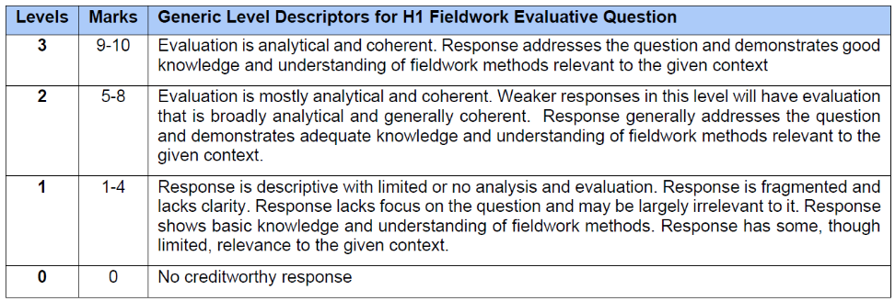

AO3

Section B
2(a) | Using Resource 4, describe the trends of the Global Fast Fashion Market. | [6]
Award 1 mark for every description of the trend.
Award a maximum of 1 additional mark for further development of each point.

Possible responses include:

- The global fast fashion market is projected to increase continuously from 2023 to 2033. [1]
- The market is expected to grow from USD 61.2 billion in 2023 to USD 254.1 billion in 2033, an overall increase of USD 192.9 billion. [1]
- The annual increase in market size becomes larger over time, indicating an accelerating rate of growth. [1]
- For example, the market increases by only USD 9.4 billion between 2023 and 2024 (61.2 to 70.6), but by USD 33.7 billion between 2032 and 2033 (220.4 to 254.1). [1]
- Apparel remains the dominant product category throughout the forecast period, while footwear and accessories account for smaller shares. [1]
- Apparel consistently occupies the largest proportion of the market every year, followed by footwear, with accessories remaining the smallest segment from 2023 to 2033. [1]

AO2

2(b) | With reference to Resource 4, suggest how these trends might influence sustainable development. | [4]
Award 1 mark for each suggestion to how the trends might influence sustainable urban development.
Award 1 additional mark for the further development of each point, where applicable.

Possible responses include:
- [Textile waste] The rapid growth of the fast fashion market is likely to increase the amount of textile waste generated in cities. [1]
- As more clothing is produced and consumed, more garments will be discarded, placing greater pressure on urban landfills and waste management systems, making it more difficult for cities to achieve environmental sustainability. [1]
- [Production Demands] The continued dominance of apparel in the fast fashion market is likely to increase the demand for clothing production and distribution. [1]
- This may lead to greater consumption of resources such as water and energy, may deplete natural resources and increase environmental degradation, reducing the long-term sustainability of cities. [1]
- [Manufacturing and transport demands] Manufacturing and transporting garments require energy, much of which comes from fossil fuels. This increases greenhouse gas emissions, contributing to climate change and making it more difficult for cities to achieve environmentally sustainable development. [1]
- [Employment – positive and negative] The growing fast fashion market is likely to increase employment in urban retail, logistics, warehousing and recycling industries. This can improve incomes and stimulate economic growth, supporting the economic pillar of sustainable urban development. [1]
- However, due to fast fashion being cheaper, the amount of income gained may not be high for employees, reducing their ability to cope with urban economic demands. [1]

AO1

2(c) | Describe two differences between a linear and circular economy. | [4]
Award 1 mark for each difference described.
Award 1 additional mark for further development of each point, where applicable.

Possible responses include:
- A linear economy follows a "take–make–dispose" model, whereas a circular economy aims to keep resources in use for as long as possible. [1]
- In a linear economy, raw materials are extracted, manufactured into products, consumed and then discarded as waste. In contrast, a circular economy seeks to minimise waste by designing products to be reused, repaired, refurbished or recycled so that materials remain in the production cycle. [1]
- A linear economy relies heavily on the continuous extraction of new natural resources, whereas a circular economy reduces the need for virgin resources. [1]
- Linear economies depend on a constant supply of raw materials to produce new goods, leading to resource depletion and greater waste generation. In contrast, circular economies recover and reuse existing materials, conserving natural resources while reducing pollution and environmental impacts. [1]

AO1

2(d) | With reference to Resource 5, explain how the ‘Garbage City’ acts as a solution to Cairo’s urban waste problems. | [6]
Award 1 mark for each explanation to how the city acts as a solution.
Award 1 additional mark for further development of each point, where applicable.

Possible responses include:
- [High recycling rates] The Zabaleen recycle or reuse 80–85% of the waste they collect, compared to the formal sector's recycling rate of 20% [1]. By recovering a much larger proportion of Cairo's waste, less waste is sent to landfills, reducing pressure on the city's waste disposal facilities and helping to address Cairo's urban waste problem. [1]
- [Variety of materials] The infographic shows that the Zabaleen recover plastic, paper, glass, metals and organic waste. By sorting and recovering these materials instead of disposing of them [1], valuable resources are diverted from the waste stream and can be reused or recycled, reducing the overall volume of urban waste [1].
- [Organic waste] The infographic shows that organic waste is one of the materials recovered by the Zabaleen. Instead of being sent to landfills where it would decompose and generate pollution, organic waste can be reused, such as for compost or animal feed [1]. This reduces the environmental impacts associated with urban waste while recovering value from materials that would otherwise be discarded [1].
- [Location] Resource 5 shows that Manshiyat Naser is located about 5 km northeast of Cairo city centre, where the Zabaleen collect and process much of the city's waste [1]. By transporting waste to a dedicated recycling hub, waste is removed from residential and commercial areas, helping to keep the city cleaner while allowing waste to be sorted and recycled more efficiently [1].

AO2

2(e) | Using Resource 6, describe the living conditions of ‘Garbage City’. | [5]
Award 1 mark for each description of the living conditions.
Award a maximum of 1 additional mark for further development of each explanation, where applicable.

Possible responses include:
- [Poor Quality] The housing in ‘Garbage City’ appears to be poor quality, with many closely packed, unfinished-looking brick and concrete buildings. [1]
- [Narrow streets] The streets are narrow and congested, with buildings located very close to the roads. The presence of pedestrians, vehicles and carts further reduces the available space, making movement through the neighbourhood difficult. [1]
- [Waste] There are large quantities of waste accumulated along the streets, including piles and bags of waste outside buildings. This creates an unclean and visually unpleasant living environment for residents. [1]
- [Overcrowded] The neighbourhood appears to have high levels of human activity and crowding, with numerous people, including children, visible within the relatively narrow streets. [1]
- [Open Windows] Some of the houses do not have windows which will expose people living in there to weather conditions and possibly vector-borne diseases. [1]

AO2

2(f) | With reference to Resource 7, suggest how community actions can enhance the image of cities. | [5]
Award 1 mark for each suggestion to how community actions can enhance the image.
Award a maximum of 1 additional mark for further development of each explanation, where applicable.

Possible responses include:
- [Visual Image] Community-led art projects can improve the visual image of a city. In Resource 7, residents of ‘Garbage City’ worked with artist eL Seed to create the Perception mural across more than 50 buildings. This transformed parts of the neighbourhood into an area of artistic interest [1].
- This also helps to challenge negative perceptions of the area as dirty and poorly developed [1].
- [Increased visibility] Community actions can attract visitors and increase the visibility of a neighbourhood. The Perception mural attracted tourists, photographers and international media attention. This brings more people to the area and allows outsiders to see the community beyond its reputation as ‘Garbage City’, improving the city's overall image [1].
- [Sense of pride] Community projects can strengthen residents’ sense of pride in their neighbourhood. Residents participated in painting the mural and used it to highlight the important role of the Zabaleen in recycling Cairo's household waste. This increases community pride [1].
- As residents feel more connected to the location, they will further contribute to presenting and creating a more positive identity of their neighbourhood to outsiders [1].
- [Change stereotypes] Community action can change negative stereotypes about disadvantaged areas. The mural was specifically created to challenge negative stereotypes about ‘Garbage City’ and highlight the contribution of the Zabaleen to Cairo's environmental sustainability [1].
- By changing how outsiders perceive the community, such bottom-up initiatives can make the city appear more inclusive and liveable [1].

AO1

Section C
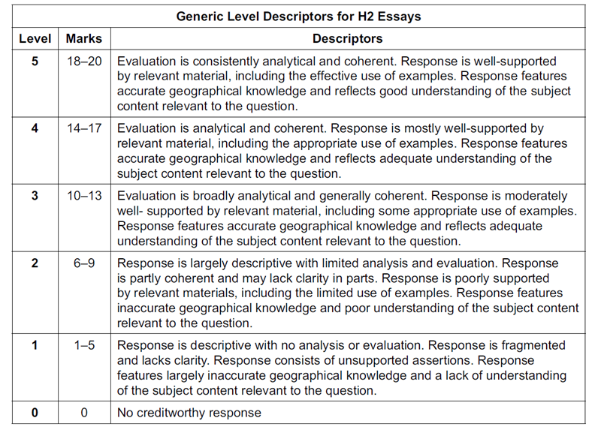
3 | ‘For climate change responses to be effective, cooperation among key actors is essential.’  Evaluate this statement.  Possible Approach:  Stakeholders – State, NGOs, Firms  EVALUATION APPROACH 1: ADAPTATION VS MITIGATION  Cooperation is more essential for mitigation  - Greenhouse gas emissions – global issue  - Emission reductions require collective action  - Stakeholders – Governments, NGOs, Firms  Adaptation doesn’t always require cooperation  - Often reliant on state actions  - Coastal protection, flood management  EVALUATION APPROACH 2: COOPERATION VS OTHER DETERMINANTS  Cooperation is essential as it mobilises  - Funding  - Expertise  - Technology  - Coordinated Emissions reductions  But beyond Cooperation, Political Commitment and Institutional Capacity is also important  - Lack of commitment  - Developing states lacking finance and technology  Levels marked using Generic Level Descriptors for 20m H2 essays.  AO3 | [20]
4 | ‘Compared to cities in low-income countries, cities in high-income countries are generally better able to achieve high levels of urban liveability.’  Evaluate this statement.  Possible Approach:  EVALUATION APPROACH 1: Levels of development  Cities with low-income countries focus on brown agenda – harder to achieve liveability at high levels. They are also limited in terms of financial resources, weaker governance and rapid urbanisation.  EVALUATION APPROACH 2: OTHER SIDE - Level of governance also matters  Cities with strong governance – willingness to plan, incorporate inclusive policies and efficient institutions generally are better able to improve liveability.  EVALUATION APPROACH 3: OTHER SIDE - Looking at stakeholders – subjective  Very few cities can achieve liveability across every dimension as it is a subjective experience. This includes both cities in low-income and high-income countries. So, when looking at different dimensions, it is possible for cities of either low-income/high-income to achieve high levels of urban liveability.  Levels marked using Generic Level Descriptors for 20m H2 essays.  AO3 | [20]

